PATHFINDER – Paving the way for Digital Learning in Higher Education with Enterprise Community Development
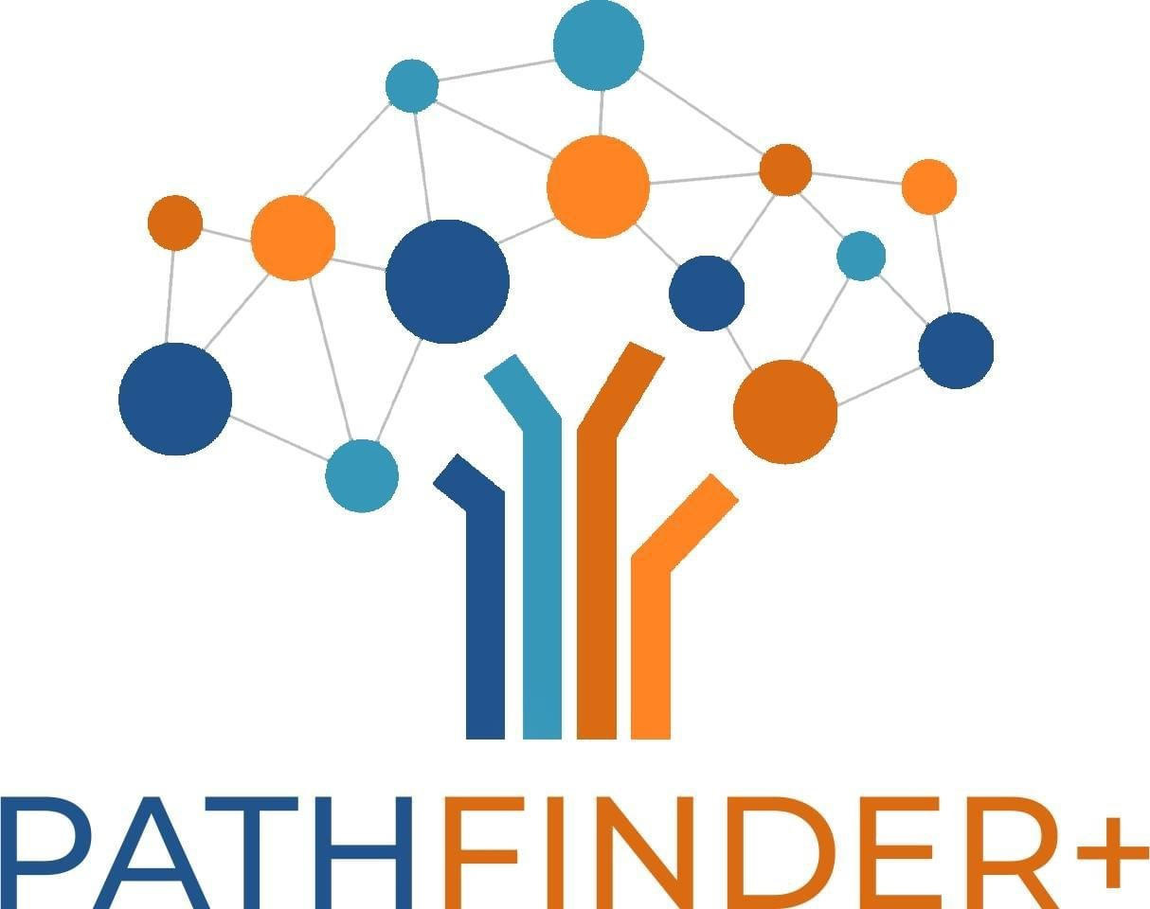
Project ID 2023-1-ES01-KA220-HED-000161343

WP2 – Toolkit PATHFINDER:

Toolkit in Higher Education for enterprise community development

Prepared by UPV team and Fundeun, WKO, KTU and UCLL.

This project has been cofunded with support from the European Commission. This publication reflects the views only of the author, and the Commission cannot be held responsible for any use that might be made of the information contained therein. Project ID 2023-1-ES01-KA220-HED-000161343

Project acronym | PATHFINDER+
Project full name | “Paving the way for Digital Learning in Higher Education with Enterprise Community Development”
Project duration | 24 months
Project coordinator | FUNDEUN
Deliverable title | Toolkit in Higher Education for enterprise community development
Work Package | WP2
Nature of deliverable | Working document
Dissemination Level | Public
Author(s) and Institution(s) | Payá, Virginia (FUNDEUN); Lafont, Rafael (FUNDEUN); De La Poza, Elena (UPV); Alcaide, Mª Ángeles (UPV); Stankevičiūtė, Živilė (KTU); Mentens, Chlöe (UC Limburg); Schabereiter, Reiner (WKO)
Recommended citation | Payá, Virginia (FUNDEUN); Lafont, Rafael (FUNDEUN); De La Poza, Elena (UPV); Alcaide, Mª Ángeles (UPV); Stankevičiūtė, Živilė (KTU); Mentens, Chlöe (UC Limburg); Schabereiter, Reiner (WKO)
Submission Date | 2/04/2025

Log of reviews
To ensure the quality and correctness of this deliverable, we implied an internal and external review.
Version | Date | Status | Author(s)
V1 | 16/01/2025 | Draft | UPV & Fundeun, WKO, KTU, UCLL
V2 | 02/04/2025 | Draft | WP2 Members
V3 | From May - October | Draft | Target
V4 | Nov/Dec 2026 | Final | Advisory Board

Table of Contents

Unit 1 - Introduction 4
Unit 2 - Tool classification 4
Unit 3 – General tools for entrepreneurship 6
SWOT analysis 6
Gantt charts 7
SMART goals 8
PESTEL analysis 8
Additional Entrepreneurial Tools 9
Unit 4 - Pathfinder community-led tools 10
1. PATHFINDER+ Community-led Concept Note 10
2. PATHFINDER+ Business Model Canvas 13
3. PATHFINDER+ Stakeholder map to build your community 17
3.1. PATHFINDER+ Digital Mapping Tool: How to build your Network? 20
4. PATHFINDER+ Sustainability reporting and dashboard 25
5. PATHFINDER+ Participatory Impact Assessment Tool 44
Unit 5 – Case studies 47
Case Study 1: Mondragon Cooperative Corporation, Spain 48
Case Study 2: Pla Buits Urban Gardens, Barcelona, Spain 48
Case Study 3: Grow Green, Manchester, UK 49
Case Study 4: Enercoop, France 49
Conclusion 50
References 50

Unit 1 - Introduction
This toolkit is a practical resource designed to support community-led enterprises in developing, growing and sustaining their initiatives. Running a community-driven business comes with unique challenges and opportunities, requiring a balance of entrepreneurial thinking and collective action. This toolkit brings together a range of tools to help navigate that journey, combining well-established business strategies with approaches specifically developed by the Pathfinder Project to meet the needs of community enterprises.
Inside, you will find a selection of entrepreneurial tools that can be adapted to different contexts, alongside real-world case studies that show how these methods have been successfully applied. These case studies provide insights into the practical aspects of implementation, highlighting both the successes and the challenges faced by community-led initiatives. By combining theory with lived experience, this toolkit offers a comprehensive guide for those looking to strengthen their projects.
Rather than being a rigid step-by-step manual, this resource is designed to be flexible and accessible, allowing users to explore the tools that are most relevant to their needs. Whether starting a new initiative, seeking solutions to specific challenges or looking for ways to refine existing practices, community leaders can use this toolkit to gain inspiration, apply proven methods and develop strategies that align with their goals.
By bringing together knowledge, experience and practical guidance, this toolkit aims to empower those working in community-led enterprises to build sustainable, resilient and impactful initiatives.

Unit 2 - Tool classification
Social entrepreneurs work to create sustainable solutions for social and environmental challenges. Unlike traditional entrepreneurs, they prioritize social impact over profit. To effectively manage their ventures, they require specialized tools that align with their mission.
This essay classifies these tools into four categories:
- Collaborative tools
- Sustainability tools
- Scope tools
- Impact measurement tools
Each category serves a distinct function and is essential for a successful social enterprise.
Collaboration is fundamental for social entrepreneurs as they work with various stakeholders, including NGOs, governments and community members. Tools like Slack and Microsoft Teams facilitate real-time communication and coordination, while Google Drive and Trello support document sharing and project management. Miro and MURAL aid in brainstorming and co-creation with distributed teams. These tools enhance teamwork and efficiency, but they require internet access and some training, which may limit their use in certain areas.
Sustainability is a core principle for social enterprises and specific tools help in measuring and improving environmental and financial sustainability. The B Impact Assessment evaluates a business’s impact on workers, customers and the environment, while the Global Reporting Initiative (GRI) Standards provide frameworks for sustainability reporting. Ecochain and OpenLCA analyze and reduce environmental footprints. These tools ensure long-term viability and transparency, but they can be complex and time-consuming to implement.
Scope tools help social entrepreneurs analyse market opportunities, identify beneficiaries and refine their business models. The Business Model Canvas (Social Enterprise Edition) helps define and adjust social business strategies, while the Lean Startup Methodology supports iterative development and validation. Pestel and SWOT Analysis assist in assessing external and internal factors. These tools provide clarity on mission alignment and strategic decision-making but require continuous updating as conditions change.
Measuring impact is crucial for social enterprises to demonstrate success and attract funding. The Theory of Change helps articulate social impact strategies, while Social Return on Investment (SROI) quantifies social value in monetary terms. The Impact Management Project (IMP) provides standardized impact measurement guidelines. These tools strengthen accountability and transparency, though they can be resource-intensive and may struggle to measure intangible social impacts accurately.
Table 1 shows a classification of social enterprise tools, including examples, advantages and disadvantages. The table categorizes these tools into four key areas: collaborative tools, sustainability tools, scope tools and impact measurement tools. Each tool is serving a specific purpose in managing a social enterprise effectively.
Additionally, different tools may be more suitable depending on the stage of the company's life cycle. For instance, scope tools are particularly useful in the early stages when entrepreneurs are refining their business model and assessing market opportunities. Collaborative tools become essential as teams grow and require efficient communication and coordination. Sustainability tools gain importance once the business starts operating and seeks to ensure long-term viability. Finally, impact measurement tools are crucial in more mature phases, when demonstrating social value and securing funding becomes a priority.
Table 1. Tool classification
Tool category | Examples | Advantages | Disadvantages
Collaborative tools | Slack, Microsoft Teams, Google Drive, Trello, Miro, MURAL | Enhances teamwork & efficiency | Requires internet & training
Sustainability Tools | B Impact Assessment, GRI Standards, Ecochain, OpenLCA | Ensures long-term viability & transparency | Complex data collection
Scope Tools | Business Model Canvas (Social Enterprise Edition), Lean Startup Methodology, Pestel Analysis, SWOT Analysis | Clarifies market feasibility | Requires continuous updates
Impact Measurement Tools | Theory of Change, SROI, Impact Management Project | Strengthens accountability & funding | Can be resource-intensive

Unit 3 – General tools for entrepreneurship
Entrepreneurship is a dynamic field that requires strategic planning, risk assessment and continuous improvement. To navigate the complexities of starting and managing a business, entrepreneurs utilize various tools designed to enhance decision-making and efficiency. Some of the most traditional and widely used tools, playing a crucial role at various stages of entrepreneurship, include SWOT analysis, Gantt charts, SMART goals, and PESTEL analysis.
This unit highlights these 4 strategic tools, widely studied in the literature and used in practice, that help entrepreneurs structure their decision-making processes. These tools were not developed by the Pathfinder Project, nor are they exclusive to community entrepreneurs. Therefore, this unit focuses on recognizing them rather than providing in-depth instructions on their use. Entrepreneurs can find extensive resources—including tutorials, case studies, and best practices—on various online platforms.

SWOT analysis
Figure 1. SWOT Analysis
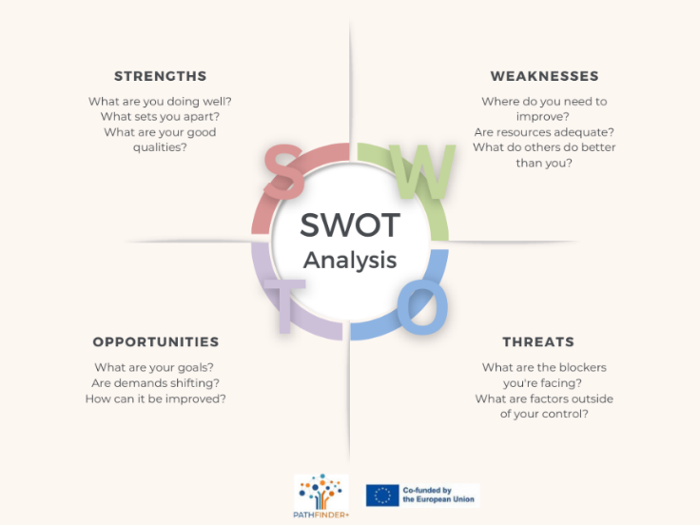
SWOT analysis is a widely used strategic planning tool that helps entrepreneurs assess their internal strengths and weaknesses, as well as external opportunities and threats. By systematically evaluating these four factors, businesses can develop strategies that leverage strengths, mitigate weaknesses, capitalize on opportunities and counteract threats.
One of the primary advantages of SWOT analysis is its simplicity and adaptability. Entrepreneurs can use it to make informed decisions about market entry, product development and competitive positioning. However, its qualitative nature can be a drawback, as it often relies on subjective judgments. Additionally, without proper follow-up actions, a SWOT analysis may remain a theoretical exercise rather than a driver of strategic change.
When can it be a useful tool?
SWOT analysis is particularly useful in the early stages of a business when entrepreneurs need to assess the viability of their idea and identify potential challenges. It also adds value during key decision-making moments, such as launching a new product, entering a new market or reassessing a business strategy after unexpected changes in the environment. For social entrepreneurs, using SWOT analysis can help align their mission with market opportunities while addressing community needs.

Gantt charts
Figure 2. Gantt Chart
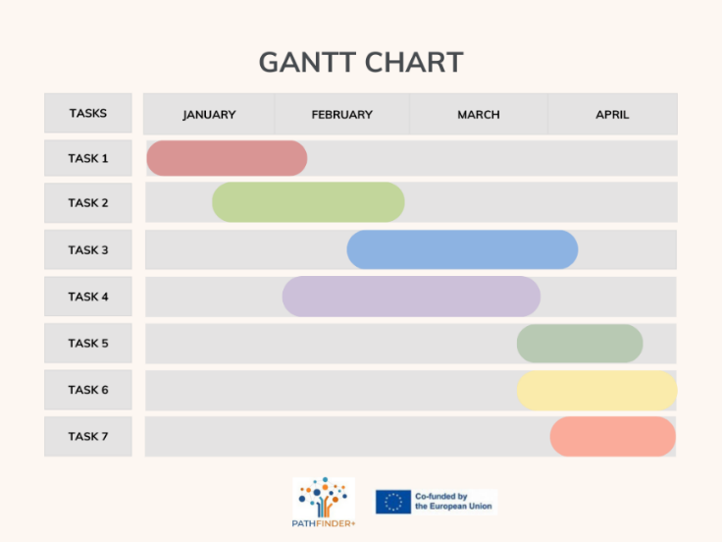
Gantt charts are essential tools for project management, providing a visual representation of tasks, timelines and dependencies. Entrepreneurs use Gantt charts to plan product launches, marketing campaigns and operational processes. By clearly outlining deadlines and responsibilities, these charts enhance coordination and accountability within a team. For example, an entrepreneur might use a Gantt chart to track the steps involved in launching a new product, from market research to the final release, ensuring that every phase Is completed on time.
Despite their effectiveness, Gantt charts can become complex and difficult to maintain, especially in rapidly changing environments. If tasks and deadlines shift frequently, the chart requires constant updates, which may lead to inefficiencies. Moreover, Gantt charts focus on scheduling rather than resource allocation, making them less useful for financial planning.
When can it be a useful tool?
Gantt charts are particularly valuable when managing complex projects with multiple tasks and team members. They help entrepreneurs ensure that all tasks are completed according to schedule, improving overall project efficiency and helping avoid delays.

SMART goals
Figure 3. SMART Goals
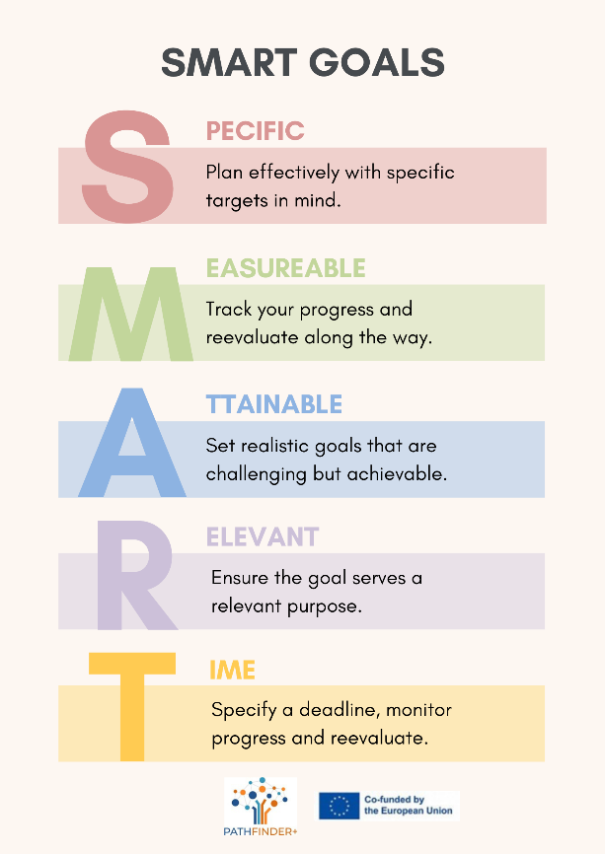
The SMART framework (Specific, Measurable, Achievable, Relevant, and Time-bound) helps entrepreneurs establish clear and actionable goals. This method ensures that business objectives are well-defined and trackable, improving focus and motivation.
The strength of SMART goals lies in their structured approach, which prevents vague or unrealistic aspirations. However, the rigid nature of the framework can sometimes limit creativity and adaptability. In fast-paced industries, setting highly specific and time-bound goals may not always align with unpredictable market conditions.
When can it be a useful tool?
The SMART framework is particularly useful when entrepreneurs need to set clear and measurable targets, such as in the early stages of a project or when launching a product. It helps to keep teams focused on key objectives and track progress. However, it may not be as effective when business conditions are uncertain or when flexibility is needed.

PESTEL analysis
Figure 4. PESTEL Analysis
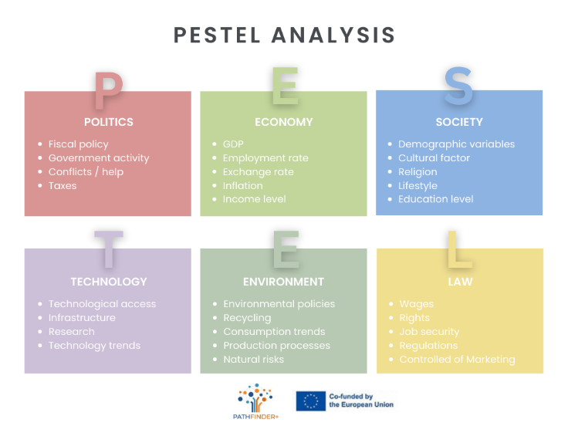
PESTEL analysis (Political, Economic, Social, Technological, Legal and Environmental) is a strategic tool used to assess macro-environmental factors that can influence a business. Entrepreneurs use PESTEL to anticipate external changes and adapt their strategies accordingly.
The advantage of PESTEL analysis is its comprehensive nature, allowing businesses to identify potential risks and opportunities beyond their internal environment. However, like SWOT, it is largely qualitative and requires ongoing monitoring to remain effective. Additionally, external factors can be unpredictable, making long-term forecasting challenging.
When can it be a useful tool?
PESTEL analysis is particularly useful when entrepreneurs are considering entering a new market or launching a new product in a dynamic environment. It helps identify external factors that could impact the business, such as changes in government regulations, economic shifts, or social trends. This tool is valuable in the early stages of planning, or when evaluating long-term strategies in response to global or local changes.

Additional Entrepreneurial Tools
Beyond these primary tools, entrepreneurs use various other frameworks to enhance business efficiency. Business Model Canvas, for example, provides a comprehensive overview of a company’s value proposition, customer segments and revenue streams. Lean Startup methodology emphasizes iterative product development and market validation. Financial forecasting tools like break-even analysis help assess profitability and risk.
While these tools offer structured approaches to decision-making, they are not foolproof. Entrepreneurs must remain flexible and critical in their application, avoiding over-reliance on any single tool. The most successful business leaders combine these frameworks with real-world experience, industry insights and adaptability.

Unit 4 - Pathfinder community-led tools
We believe that all the tools mentioned above, as well as any other that can be applied to any traditional project, can also be applied to social and community entrepreneurship projects. However, in relation to our community-led entrepreneurship project, and according to the research that we have carried out, we consider that the following 5 tools are essential for the development of cultural-environmental-territorial-social projects, and therefore are of great contribution to social entrepreneurs.
It should not be forgotten that each social project is unique and requires adapting to the characteristics and needs of the community in which it is developed, which is why Pathfinder has selected the following 5 specific tools to help entrepreneurs design their community-led projects:
- Community-led concept note
- Pathfinder business model canvas
- Community-led stakeholder map to build your community
3.1. Digital Mapping Tool: How to build your Network?
- Sustainability report and Pathfinder dashboard of indicators
- Participatory Impact Assessment Tool
Below is a description of each of the tools proposed by Pathfinder and a guide or practical examples applied to community entrepreneurship projects to help entrepreneurs use and implement them for the benefit of their projects.

PATHFINDER+ Community-led Concept Note
A concept note is a short and concise document presenting a project idea, usually the first step in proposing a project before submitting a full application. It should therefore summarise the key points of the proposed project.
- Why is this tool relevant for community-led projects?
Community-led projects are usually characterised by the lack of financial resources to carry them out and by their difficulty in accessing traditional sources of funding. That is why the use of the concept note becomes relevant in this type of project.
The concept note is like a letter of introduction of the project to potential funders or sponsors, so it must summarize its purpose and results, and above all it is essential to show that the objectives of the community-led project coincide with the type of initiatives you want to support.
Community-led concept note is also a relevant tool to obtain financing both in community-led projects where there is a market and in those projects without a market, since in all of them it is essential to allocate public funds or attract private resources.
- Why is this tool used for social entrepreneurship projects?
Social projects often require funding from external sources, especially from public entities or organizations, in the form of grants, and from private funders, in the form of donations or crowdfunding. All of these funders often receive numerous requests for funding, the concept note allows them to simplify the review process by making a quick first evaluation of the requests, selecting projects aligned with their focus areas, in addition to the consequent saving of time and valuable resources.
Use this tool to effectively summarize the main ideas of the project and be able to send them to potential social funders so that they have a first approximation to it.
Here there are 4 key aspects to capture the attention of funders and potential grantmakers and secure funding for your social projects:
1: Understand and tailor the concept note to the potential funder and grant requirements
Aligning your concept note with the specific requirements and preferences of the funder will significantly increase your chances of obtaining funding. Every concept note is an opportunity to showcase and be able to fund the innovative and transformative work your organization is doing. Clarity is key, use simple, jargon-free language to effectively convey your ideas.
2: Define the core components of your project
Identify the problem or need your organization or community project aims to address, as well as its objectives and expected outcomes.
3: Present a compelling methodology and demonstrate its sustainability
Clearly explain how your project will create a positive impact and contribute to addressing the identified problem. Highlight innovative aspects or unique approaches. Funders want to be sure that their funding will be used effectively and that the proposed project has a sustainable future. Describe the feasibility of the project by analyzing the resources, expertise, and partnerships your nonprofit can offer.
4: Outline an estimated budget
Clearly outline the major expense categories. Be transparent and realistic in your budget estimates and provide a breakdown of how funds will be allocated.

Below is a template (Figure 5) of a community-led concept note to guide social entrepreneurs in designing their concept notes on their community-led entrepreneurship projects:
Figure 5. Template of Pathfinder community-led concept note
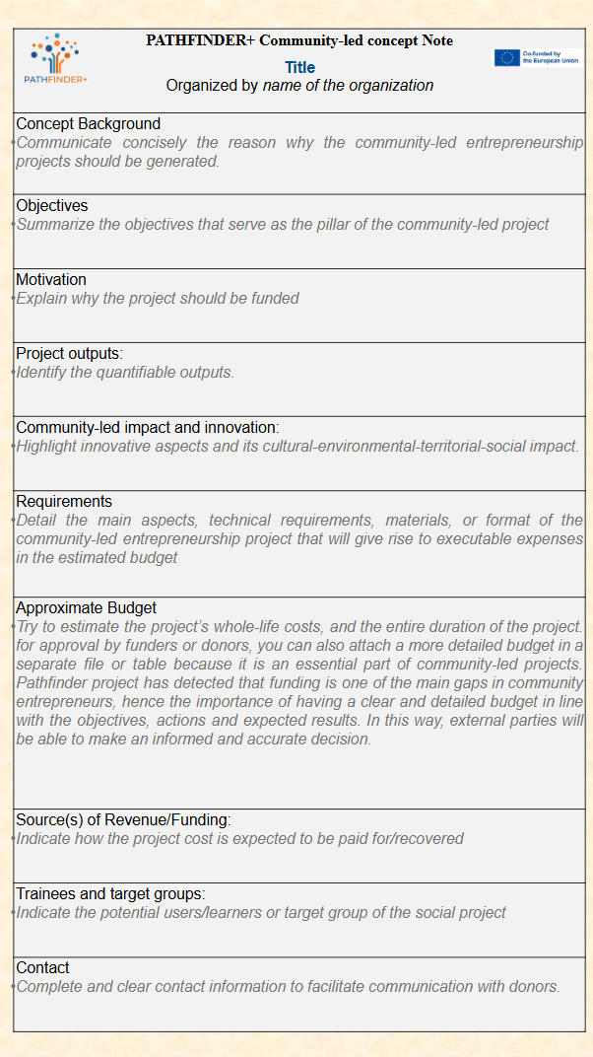
      - Final recommendation: Investigate the profile of key stakeholders.
It is recommended that potential users of this concept note tool who lead community projects provide themselves with a list of possible key stakeholders, in order to study the profile of each of them and identify what each one can contribute to the project, either economically or with any other type of collaboration.
In particular, it is important to know the profile of potential key funders, to know their interests, motivations and other projects financed by them. In this way, social entrepreneurs will be able to customize a concept note for each key funder, highlighting those aspects that they consider can attract the most attention of their funder, with the aim of obtaining the necessary economic resources for the development of the community project.

PATHFINDER+ Business Model Canvas
The Canvas model is a tool that allows the design and development of business models in a dynamic and visual way, embodied in a diagram called Canvas Model by A. Osterwalder (Osterwalder et al., 2010). This canvas is structured in grids, each one dedicated to a fundamental aspect of the business model, such as the value proposition, income, expenses, acquisition channels, among others. In these grids, ideas are continuously added and removed until a final version is achieved. It also simplifies the complexity of analysing and creating business models, making it accessible to entrepreneurs of all levels. This model is ideal for transforming an idea into a concrete project, visualising how this idea becomes a real and sustainable business. Moreover, the model changes and evolves. As the business grows, as more is discovered about customers and new ideas emerge, the canvas model will be adjusted, facilitating adaptation and continuous innovation. This model is integrated into the lean-startup methodology, which is based on finding and fostering new ways to create, deliver and capture customer value through validated learning.
- How to generate a community-led business canvas model?
Generally, community-led business canvas models show the interconnection between the 9 basic aspects of a business model: key partners, key activities or delivery, key resources, cost structure, revenue streams, customer relationships, customer segments, channels, and value proposed. In the case of community-led projects, this last aspect is identified as community-led value propositions + social/environmental/cultural impact. Because in this type of project not only do the proposal itself generate added value, but they also generate a positive impact on the community of some kind, whether social, environmental, cultural or territorial benefit.
The following shows what kind of questions a community-led entrepreneur or social stakeholder could ask in order to complete his or her own social business canvas model and Figure 6 shows several generic examples for a community entrepreneur to complete the canvas model of his social project
1. Customer segment --> Who are we creating value for? Who are our most important customers?
2. Community-led value proposition + Social/environmental/cultural impact --> This is the key piece of the whole business model. The value proposition or competitive advantage is the reason why the customer will buy from us and not from someone else, i.e. what will make the project enterprise sustainable, different and innovative. You can innovate in different aspects, such as the revenue model, business alliances, production processes, delivery of the product/service, and branding... We must answer questions such as: What value are we delivering to our customers?, What problem are we solving?, What is the need we satisfy?, What type of product/service do we offer?
3. Channels --> With which channels can we reach our customers? Which channels work best? Which of these channels are the most profitable?
4. Customer relationship --> What is the relationship we have with each of our customer segments?, What kind of relationship do they expect?, What is the cost?
5. Revenue stream --> What is our main revenue stream?, How will our customers pay? What are our customers willing to pay for?
6. Key resources🡪 We must be cautious and prudent when defining the resources we must have when carrying out the activity. We must always think about how to optimise them, i.e. try to achieve the maximum possible productivity at the minimum cost. We must answer the following questions: What essential resources does our value proposition require?
7. Key activities / delivery --> What core activity does our value proposition require? What are the key deliverables we provide to our community?
8. Key allies /partners --> Who are our key partners in the market? Who are our suppliers?
9. Cost structure --> What are the most important costs within our business model? Which key resources are the most costly? Which key activities are the most costly?
Figure 6. Examples to complete a community-led business canvas model
Key Activities  or Delivery | Key Partners | Community-led Value Propositions  + Social/environmental/territorial Impact |  |  | Customer Relationships | Customer  Segments
- Sustainable project  - Sustainable management  - Social, territorial, environmental, cultural project/activity  - Calculate and considerate the environmental and social benefits of the intervention (and costs of not acting)  - Divulgation to institutions and citizenship  - Measurement of results  - Awareness  - Corporate social responsibility | - Non profit organizations  - Funders  - City government  - Suppliers with great knowledge about the solution and aligned with sustainability  - Private business (economic/fiscal incentives) | - Citizen support  - Social commitment  - Territorial commitment  - Environmental cooperation  - Humanitarian aid  - Risk reduction  - Accessibility  - Sustainability performance  - Social impact  - Environmental impact  - Promote social cohesion  - Local economic growth (commercial vitality)  - Energy consumption reduction  - Citizen's wellbeing improvement  - Biodiversity improvement  - Attachment to place and sense of belonging  - Reduction of crime and/or fear of crime (comfort and safety) |  |  | - Consultative approach  - Responsible communication  - Public-private partnership  - Awareness relationship  - Social responsibility  - Green consciousness | - Foundations  - Citizens, neighborhood, community  - Associations,Community organisations  - Community-led entrepreneurships  - City government
 | Key Resources |  |  |  | Channels
 | - Financial investments  - Social centre  - Training and technological tools  - Human resources  - Regulation to promote and support the development of this solution  - Tools for the acknowledge of expected impacts of the solution |  |  |  | - Website  - Networking events  - Online  - Pilot projects  - Promotion from provider companies and public organizations  - City government
Cost Structure |  |  | Revenue Streams
 |  |  | Revenues | Funding / Patron contribution
- Advertising & marketing  - Organisation of social events  - Employees  - Bonifications, incentives |  |  | - Sales  - Traditional financial sources | - Donatives  - Crowdfunding  - Partnerships  - Sponsorships  - Grants  - Subscription fees

However, depending on the type of social or community-led business/project, the basic aspects of the model may vary. In addition, the Pathfinder project, according to the results detected in its research, proposes the following Pathfinder community-led business model canvas for Community-Led Projects (Figure 7), as show below, with the aim of offering an exclusive canvas model that can guide entrepreneurs and community stakeholders to develop canvas adapted in a simple way to their community projects
Figure 7: Pathfinder community-led business model canvas
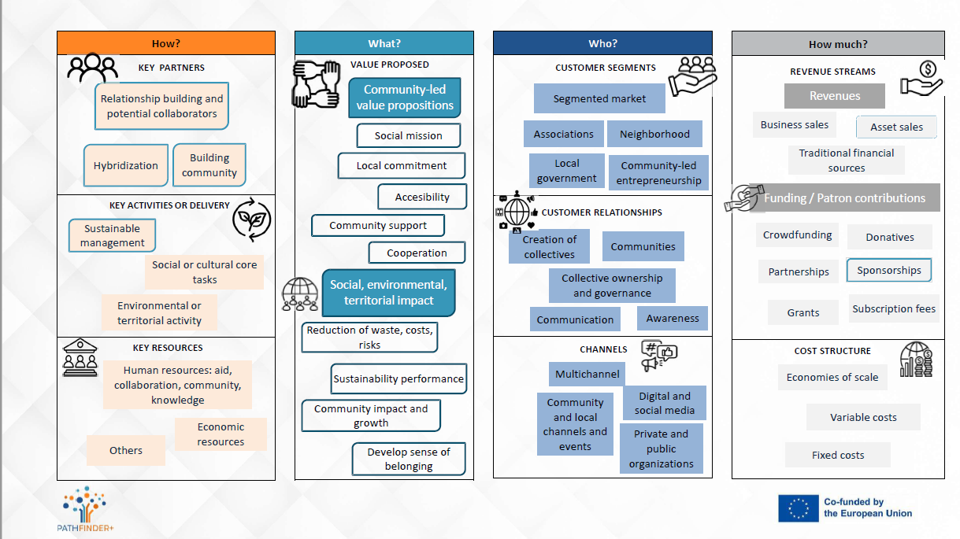
Source: Own elaboration.
Figure 8 shows an example of a social business canvas model, adapted to a real-life community-led project, which addresses the environmental and territorial objectives of social entrepreneurship: the Pla Buits urban gardens in Barcelona, ​​Spain. This model relies on the government providing land and space to local initiatives and (social) enterprises in (sometimes temporarily) unused urban public spaces. In this case, the canvas model has been simplified, as shown in Figure 8.
Figure 8. Social business model canvas from social entrepreneurship: The Pla Buits urban gardens in Barcelona (Spain) Case.
VALUE PROPOSITION
The Pla Buits scheme in Barcelona is a participatory intervention that gives the opportunity to public entities or non-profit associations to develop temporary uses and activities (1-3 years) on small plots of unused land. Out of the 14 selected projects in the first phase, nine are urban gardens. They ‘fit’ well to temporary use because no large infrastructure is needed. The Pla Buits urban gardens represent a form of social entrepreneurship: self-governed projects are given a space to flourish, contributing to urban green and related ecosystem services, while also offering a solution to social issues of community bonding, integration, and awareness-raising on food production and consumption.

VALUE DELIVERY
Only legal entities (such as neighborhood associations) can apply to a Pla Buits plot. The City Council contributes to its basic amenities (water, electricity). A successful bottom-up dynamic is essential for the success of these urban gardens; families with young children, looking for outdoor activities, play an important role in creating active communities

VALUE CAPTURE
The low cost of the unused public space assigned for these urban gardens is driving the feasibility of this model, as well as the fact that its use can be temporary. The municipality offers several support schemes, for example to pay an instructor who oversees member participation, and in one of the gardens (Illa de 3 Horts) families pay a small contribution for running costs. The density of Barcelona increases the value of these small urban green spaces for its members.

PATHFINDER+ Stakeholder map
- PATHFINDER+ Stakeholder Map
The PATHFINDER+ stakeholder map aims to provide a simple way to identify the fundamental individuals and organisations an entrepreneurial project needs to be developed. These might include, in community-led projects, a wide typology of institutions and agents the project will deal with even before the beginning of the project launch. The stakeholder map is also a reflection tool as it connects the required resources to launch the project with the agent/organization that might provide them.
- Stakeholder map: Steps to follow
Process to create a stakeholder map.
- Define the project framework: objectives, required resources, services, impact and expected outcomes. Analyse the resources and determine which ones are to be provided by external actors.
- Identify and classify the stakeholders in two groups: The first one is your target group, that is the group your project will address (Direct beneficiaries, indirect beneficiaries, related beneficiaries); the second one will be built up with the strategic agents that will support the project with resources or services needed for the project development (investors, similar ONG´s willing to collaborate with your project, local businesses, local public organisations, experts and consultants, media, politicians, community members, etc…).
- Carry out interviews with local community to find out additional stakeholders that you might forget to consider.
- Consider taking into account the cultural and social context of the local community.
- Categorize: Select two dimensions to categorize the stakeholders. For community-led projects interest in the aim of the project and impact are the most frequent factors.
- Map the stakeholders according to their influence in the project. Those closer to the center will be more relevant to the project.
- Factors-tips to consider when creating a stakeholder map in a community-led project
This section analyses social and cultural factors that may condition the participation and interest of the stakeholder groups.
- The needs and profile of the different social groups (ethnic, language and communication channels) and the non-formal groups (families, friends, community associations or networks).
- Local culture: traditions, customs, local practices, values, beliefs…
- Groups of power and local leaders.
- Background on participation and preferred means of participation (workshops, meetings, events, interviews, online networks, etc…).
- Economic context and access to economic resources.
- Social media and the use of the technology
- Previous issues and conflicts of interest.
- The role of media in community enterprise development
As mentioned before, the media is one of the key stakeholders in a community-led project. First of all because the media is a good way to know and approach social, environmental, cultural and economic issues to adjust project approaches and address emerging needs.
A good media coverage can increase the visibility of the project and attract more participants or funders even before the project launches.
Media contribution:
- Opinion formation. The media can influence public perception and it can help shape the community´s opinion on the importance of the venture and its impact.
- Connections and networks for collaboration with other organisations and funding opportunities. Media help to build relationships with community members, stakeholders and partners as these networks require effective communication and collaboration with citizens, other businesses, community leaders, local associations, local governmental institutions.
- Transparency and accountancy. Media shares project achievements and it can increase interest in similar initiatives generating a multiplier effect in the community.
- As a platform to express opinions, concerns and aspirations, which can enrich the project with diverse perspectives.
Strategies to engage the media:
- Build relationships with local journalists.
- Write press releases to keep the media informed about project news, achievements and events.
- Use Social Media channels to complement traditional media coverage and to attract the attention of a wider audience.
Figure 9. Stakeholder map template

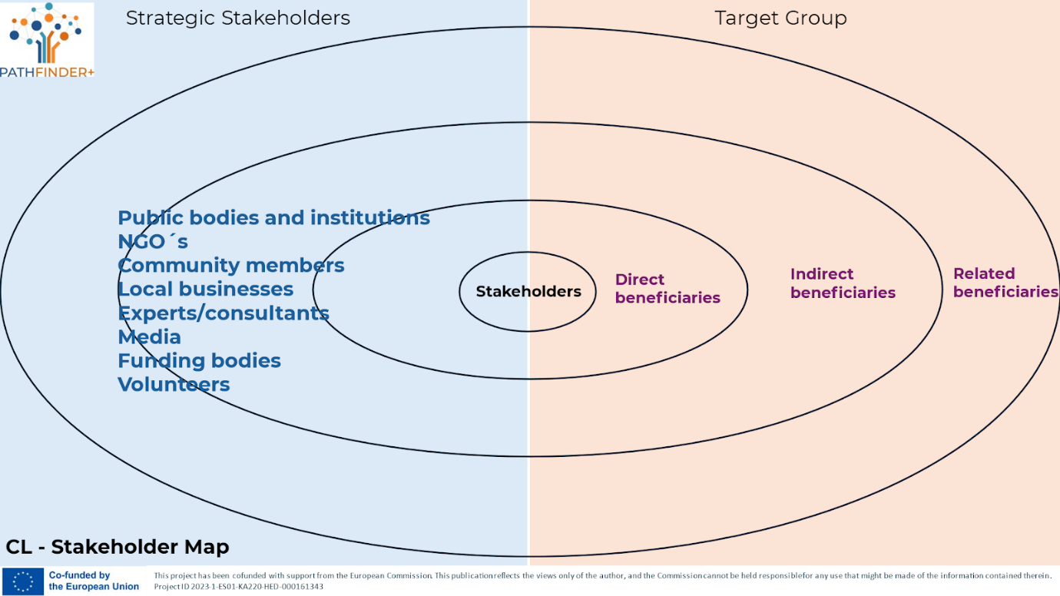

PATHFINDER+ Stakeholder Map Template

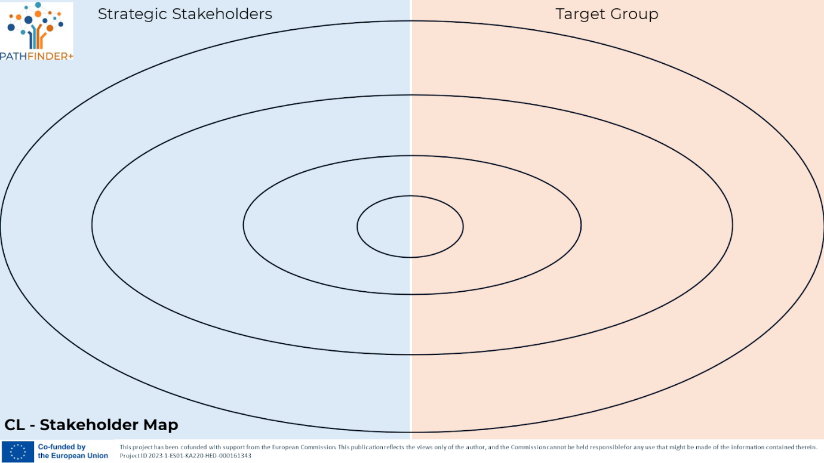

3.1. PATHFINDER+ Digital Mapping Tool: How to build your Network?
- Importance of building a strong network and community
The necessity of building a network to thrive as a community-led enterprise is inevitable. Therefore being able to create a strategic process to expand the professional connections and grow your business. Network building is important for start-ups as well as established enterprises. This process should be seen as a permanent “circle”.
As the first step to support you in your founding process, a tool for mapping and structuring your existing network, as well as planning needed new connections, is essential. A mapping tool for community-led enterprises is important for several reasons, as it can provide immense value to both the enterprises themselves and the communities they serve.
Therefore, this section presents basics on how to build impactful networks, and how to use a free online tool for mapping issues (OpenStreet Map). It also includes a practical example.
- OpenStreetMap
As a mapping tool, PATHFINDER+ suggests using open online resources. Specifically, we will show one of the most advanced functions to create a customizable map, OpenStreetMap. Therefore, this section bases on using https://www.openstreetmap.org.
OpenStreetMap is a free, editable map of the whole world that is being built by volunteers and released with an open-content license. The tool allows users to zoom into specific locations (local, national, or global).
Key Features:
- OpenStreetMap can be used for creating a customizable map. The map allows users to zoom into specific locations (local, national, or global).
- Filters and Categories: Users can filter the enterprises by type (e.g., cooperatives, social enterprises, nonprofits, etc.), location, etc..
- User Contributions and Crowdsourcing: Users are also invited to submit new enterprises to OpenStreetMap, or add community enterprises they know. This ensures that the map stays up-to-date.
- Enterprise Profiles: Each listing can have a profile with detailed information about the enterprise, including its mission, services/products, social impact, contact info, and website.
- Impact Indicators: The social and environmental impact of the enterprisesby using criteria like "number of jobs created," "percentage of local sourcing," or "environmental sustainability" can easily be added.

- How to add your company to OpenStreeMap
Everybody can be a part of the community and add entries to the database. Therefore, OpenStreetMap is a perfect mapping tool for PATHFINDER+.
Step 1: Create an account
- Go to openstreetmap.org and click on “Sign-up”. You need an email address, a username and a password.
- After registering, you´ll get some information on the available options etc.
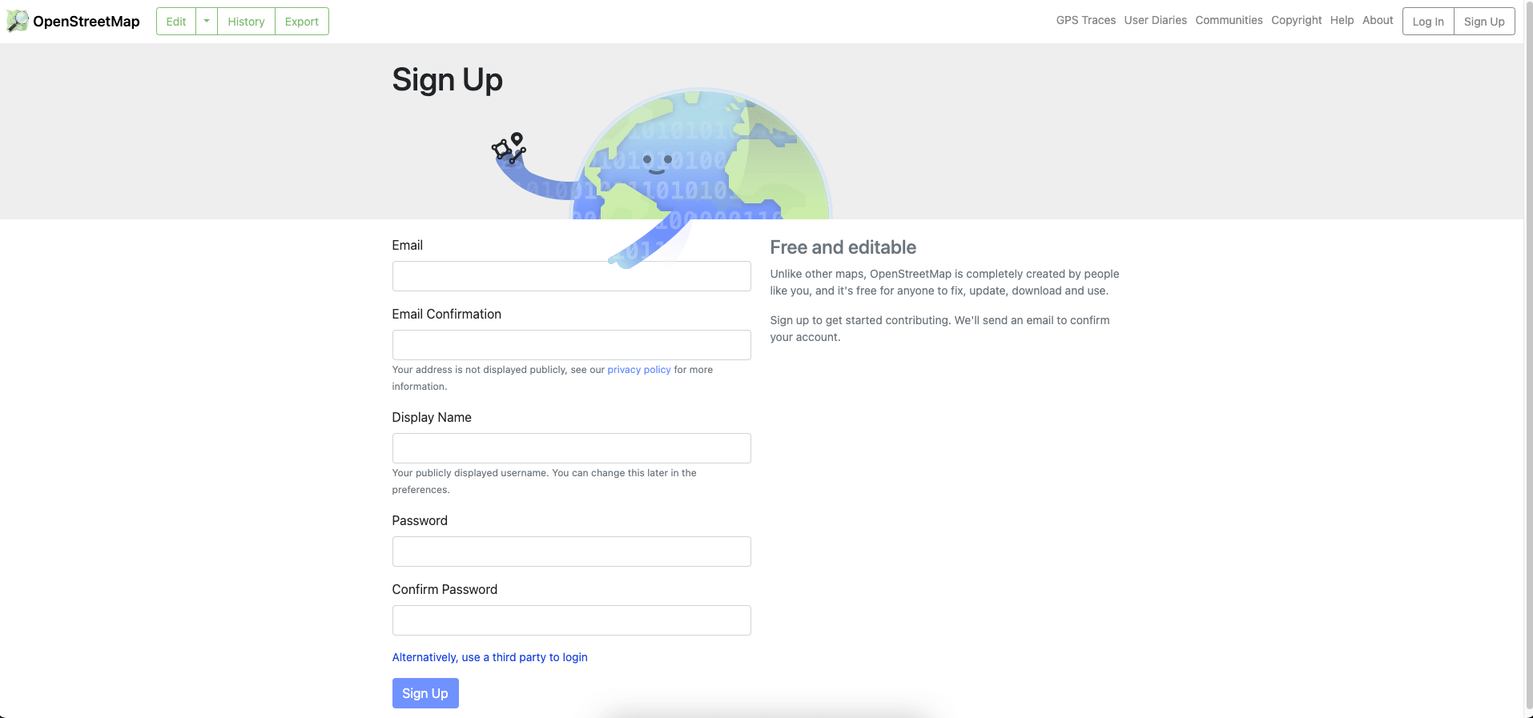
Figure 10. Login Form on OpenStreetMap

Step 2: Edit Mode
- Switch to the “Edit Mode” by clicking the button on the left upper side.
- You´ll be directed to the editor.
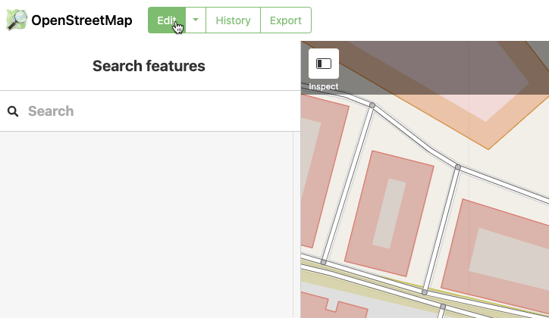
Figure 11. Starting the “Edit Mode” on OpenStreetMap

- You can switch between different modes like a satellite mode to easier find your own location. Also, overlays can be chosen in the “Background” menu.
3. Add your institution
- The overlay “Add Feature” allows you to add a “Point”, a “Line” or an “Area”. You can also change or even delete them.
  - Point: Single building or a point of interest (e.g., companies…)
  - Line: Continuous lines (e.g., roads, railroads…)
  - Area: Larger areas (e.g., parks, sports areas…)
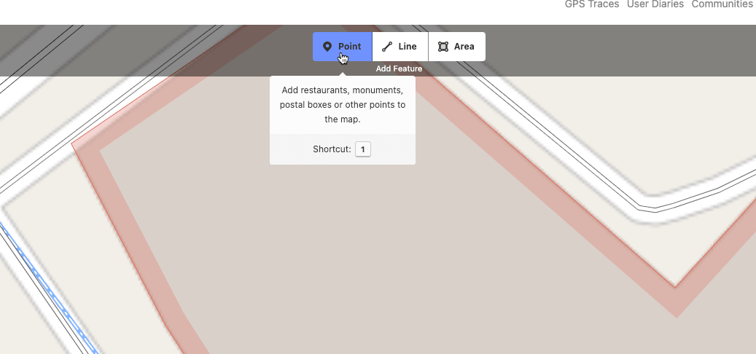
Figure 12. Adding features

- After selecting your “Point”, you can choose between numerous categories for describing and categorizing it.
- You are also allowed to add further details like opening hours, website etc.
- After everything is added, you just have to save your data by clicking on the “Save” button on the upper right corner.
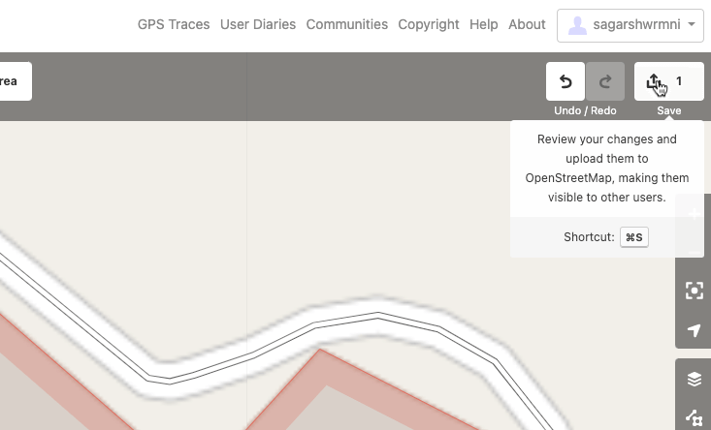
Figure 13. Saving changes

4. Comments
OpenStreeMap will ask you for adding comments sources on the left. Click ‘Upload’ and your contribution is sent. The more information and details you add, the better.
- After your data is reviewed and approved, it will be published to the OpenStreetMap database.comments
- This is a perfect solution for making your and other institutions visible - a perfect mapping tool.
- Practice example - “Stadtladen Graz”
The psychosocial service provider pro mente Steiermark GmbH supports people with mental illnesses through a variety of support services to help them get back on their feet professionally and to stabilize their health outside of inpatient care. Offers for professional rehabilitation, day-structured and hourly employment, assisted living, mobile social psychiatric care, forensics, health at work, diagnostics and advice, as well as sport and exercise, occupational health care and education are intended to enable comprehensive care, tailored to the individual needs of each person, and to promote self-determined living.
"Stadtladen Graz" is a company located in Graz (Austria), that offers one of these services. pro mente Steiermark GmbH's clients collaborate there, selling local food. In red, you can see the entry on OpenStreetMap.
Figure 14. “Stadtladen Graz” on OpenStreetMap

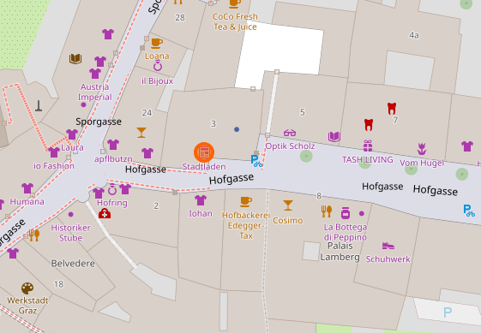

A box on the upper left side shows further information on the entry itself:
- Name
- Categories (e.g., „shop“)
- Location
- Editing information
By clicking on links at the end of the description, it's possible to check the history of this entry.
Figure 15. Further information and data history
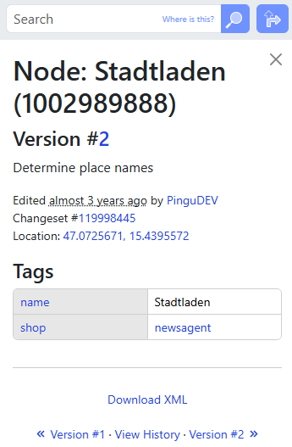

- 5 rules for building your impactful network
1. Make the Community Bigger Than the Product: Position your network around a shared mission or lifestyle, not just your product.
Example: If you sell sustainable clothing, build a community focused on environmental awareness and eco-friendly living. Host webinars on sustainability or initiate local cleanup drives to unite members beyond your products.
2. Focus on Trust and Loyalty: Build credibility by delivering consistent value and authentic communication.
Example: Engage regularly with your network through updates, genuine feedback, and exclusive offers, like a loyalty program that recognizes long-term supporters.
3. Create Opportunities for Engagement: Design interactive activities that let members contribute and feel valued.
Example: Organize hackathons, brainstorming sessions, or forums where your community can co-create ideas or initiatives for your business.
4. Diversify Your Network Connections: Include members from different industries, geographies, and expertise to add depth and innovation.
Example: Invite nutritionists, fitness trainers, and tech developers to a fitness-focused network for workout gear, introducing diverse skills to your core audience.
5. Map and Reassess Your Network Regularly: Periodically evaluate your network’s strengths, gaps, and untapped potential.
Example: Use tools like Kumu to visualize your network, identify weak links, and proactively address resource needs or underrepresented sectors.

PATHFINDER+ Sustainability reporting and dashboard

1. PATHFINDER+ Sustainability reporting and dashboard
The PATHFINDER+ Sustainability reporting and dashboard tool aims to provide a simple way to non-financial reporting that enables community-led enterprises to convey their situation and the progress toward goals on a variety of sustainability parameters, including environmental, social, economics and governance metrics. The Reporting is also about including risks and impact these risks might generate in short-term and long-term perspectives.
Several different types of sustainability reporting standards exist. Some of the more widely used frameworks for reporting on sustainability and Environmental, social, and governance (ESG) impacts include the Global Reporting Initiative (GRI) (https://www.globalreporting.org/) and UN Global Compact (https://unglobalcompact.org/)
The PATHFINDER+ team has decided to provide a broader perspective on sustainability reporting and dashboards. As a result, three examples of monitoring and reporting are provided, which you can explore. Finally, PATHFINDER+ proposes its own tool for this purpose.
So, below are examples based on other resources that you can explore on your own. Later we provide a tool, which is called “Metrics for Sustainability Dashboards in Community-Led Enterprises”.
EXAMPLES:
I. The first example – Reporting based on the Ten Principles of the UN Global Compact (https://unglobalcompact.org/what-is-gc/mission/principles)
II. The second example - Sustainability Reporting Questionnaire - is based on Sustainable supplier questionnaire prepared by Lithuanian Responsible Business Association (https://atsakingasverslas.lt/en/home/)
III. The third example - Employee Sustainability Dashboard - is based on the Global Reporting Initiative (GRI) (https://www.globalreporting.org/)

2. Example I – Reporting based on the Ten Principles of the UN Global Compact
The first example is based on the Ten Principles of the UN Global Compact.
Table 1 provides the list of ten principles (Table 2).
Table 2. The Ten Principles of the UN Global Compact (source: https://unglobalcompact.org/what-is-gc/mission/principles)
Area | Principle
Human Rights | Principle 1: Businesses should support and respect the protection of internationally proclaimed human rights; and
Human Rights | Principle 2: make sure that they are not complicit in human rights abuses.
Labour | Principle 3: Businesses should uphold the freedom of association and the effective recognition of the right to collective bargaining;
Labour | Principle 4: the elimination of all forms of forced and compulsory labour;
Labour | Principle 5: the effective abolition of child labour; and
Labour | Principle 6: the elimination of discrimination in respect of employment and occupation.
Environment | Principle 7: Businesses should support a precautionary approach to environmental challenges;
Environment | Principle 8: undertake initiatives to promote greater environmental responsibility; and
Environment | Principle 9: encourage the development and diffusion of environmentally friendly technologies.
Anti-Corruption | Principle 10: Businesses should work against corruption in all its forms, including extortion and bribery.
The information is further structured in such a way that the structure for each principle remains the same. At the beginning, each principle is briefly described (in 1-3 sentences), followed by check questions for community-led enterprises. These questions serve as guidelines/thoughts to reflect on for evaluating the journey towards sustainability that a community-led enterprise undertakes. After this, the summary table with questions for all the ten principles is provided at the end.
Principle 1. Businesses should support and respect the protection of internationally proclaimed human rights.
Respect for human rights is the right thing to do, but it is also a business issue. Not respecting human rights poses a number of risks and costs for business including putting the company’s social license to operate at risk, reputational damage, reduced productivity and morale of employees. The questions for community-led enterprises are provided in the Table 3.
Table 3. Questions for Community-Led Enterprises Regarding Principle 1.
No. | Area | Questions
1 | Providing safe and healthy working conditions | What measures are in place to ensure a safe and healthy workplace for employees?
2 | Guaranteeing freedom of association | How does the company support employees' rights to organize and join trade unions or workers' associations?
3 | Ensuring non-discrimination in personnel practices | What policies and practices are implemented to prevent discrimination in hiring, promotions, and workplace treatment?
4 | Ensuring no use of forced or child labor – | What steps does the company take to ensure that neither forced labor nor child labor is used, directly or indirectly, within its operations or supply chain?
5 | Providing access to basic health, education, and housing if not provided elsewhere | How does the company help workers and their families access essential services like healthcare, education, and housing when they are not otherwise available?
6 | Having an affirmative action program to hire victims of domestic violence | What initiatives does the company have to support and employ individuals affected by domestic violence?
7 | Making reasonable accommodations for religious observance and practices | How does the company accommodate employees' religious practices and ensure inclusivity in the workplace?
Principle 2. Businesses should make sure that they are not complicit in human rights abuses
Complicity means being implicated in a human rights abuse that another company, government, individual or other group is causing. The risk of complicity in a human rights abuse may be particularly high in areas with weak governance and/or where human rights abuse is widespread. However, the risk of complicity exists in every country. The questions for community-led enterprises are provided the Table 4.
Table 4. Questions for Community-Led Enterprises Regarding Principle 2.
No. | Area | Questions
1 | Complicity | Has the company established a monitoring/tracking system to ensure that its human rights policies are being implemented?
2 | Complicity | Does the company actively engage in open dialogue with stakeholder groups, including civil society organizations?
Principle 3. Businesses should uphold the freedom of association and the effective recognition of the right to collective bargaining
Freedom of association implies respect for the right of all employers and all workers to freely and voluntarily establish and join groups for the promotion and defence of their occupational interests. The questions for community-led enterprises are provided in the Table 5.
Table 5. Questions for Community-Led Enterprises Regarding Principle 3.
No. | Area | Questions
1 | Respect for Trade Union Rights | Does the company ensure that workers can freely join or form a trade union without fear of intimidation or retaliation?
2 | Non-Discriminatory Policies and Procedures | Are there policies in place to prevent discrimination against employees based on trade union membership or activities?
3 | Support for Workers’ Representatives | Does the company provide workers' representatives with the necessary resources to support effective collective bargaining?
4 | Non-Interference in Union Activities | Does the company allow worker representatives to perform their duties without undue interference while ensuring smooth business operations?
Principle 4. Businesses should uphold the elimination of all forms of forced and compulsory labour
Forced or compulsory labour is any work or service that is exacted from any person under the menace of any penalty, and for which that person has not offered himself or herself voluntarily. The questions for community-led enterprises are provided the Table 6.
Table 6. Questions for Community-Led Enterprises Regarding Principle 4.
No. | Area | Questions
1 | Elimination of all forms of forced and compulsory labour | How do you make sure your workers are not forced to work and can leave their jobs freely?
2 | Elimination of all forms of forced and compulsory labour | Do you give all employees clear contracts in a language they understand?
3 | Elimination of all forms of forced and compulsory labour | How do you check that your suppliers and partners do not use forced labour?
Principle 5. Businesses should uphold the effective abolition of child labour
The term “child labour” should not be confused with “youth employment” or “student work.” Child labour is a form of exploitation that is a violation of a human right and it is recognized and defined by international instruments. The questions for community-led enterprises are provided in Table 7.
Table 7. Questions for Community-Led Enterprises Regarding Principle 5.
No. | Area | Questions
1 | Child labour | How do you check the age of workers during recruitment?
2 | Child labour | How do you make sure that your suppliers and subcontractors are not using child labour and are following the same standards?
Principle 6. Businesses should uphold the elimination of discrimination in respect of employment and occupation.
Discrimination in employment and occupation means treating people differently or less favourably because of characteristics that are not related to their merit or the inherent requirements of the job. In national law, these characteristics commonly include: race, colour, sex, religion, political opinion, national extraction, social origin, age, disability, HIV/AIDS status, trade union membership, and sexual orientation. The questions for community-led enterprises are provided in Table 8.
Table 8. Questions for Community-Led Enterprises Regarding Principle 6.
No. | Area | Questions
1 | Non-discrimination | How do you make sure that qualifications and experience are the main factors in hiring and promoting employees?
2 | Non-discrimination | Who is responsible for equal employment practices in your company, and how do you share these policies with your staff?
3 | Non-discrimination | How do you make sure that job requirements don’t unfairly disadvantage certain groups of people?
4 | Non-discrimination | Do you keep records of recruitment, training, and promotions to show that all employees have equal opportunities?
5 | Non-discrimination | Do you provide training to help employees recognize and address unconscious bias?
6 | Non-discrimination | What do you do if someone in your company feels they have been discriminated against?
7 | Non-discrimination | How do you make sure employees feel comfortable raising concerns or complaints at work?
8 | Non-discrimination | Do you offer training on non-discrimination and make adjustments for employees with disabilities?
9 | Non-discrimination | Do you have programs that help employees develop new skills and grow in their jobs?
Principle 7. Businesses should support a precautionary approach to environmental challenges
Precaution involves the systematic application of risk assessment, risk management and risk communication. When there is reasonable suspicion of harm, decision-makers need to apply precaution and consider the degree of uncertainty that appears from scientific evaluation. The questions for community-led enterprises are provided in Table 9.
Table 9. Questions for Community-Led Enterprises Regarding Principle 7
No. | Area | Questions
1 | Precautionary approach | Does your company have rules to protect health and the environment, and how do you make sure everyone follows them?
2 | Precautionary approach | How does your company keep customers and others informed about possible risks, and can they ask questions or raise concerns?
Principle 8. Businesses should undertake initiatives to promote greater environmental responsibility.
The Rio Declaration says that business has the responsibility to ensure that activities within their own operations do not cause harm to the environment. Society expects business to be good actors in the community. The questions for community-led enterprises are provided in Table 10.
Table 10. Questions for Community-Led Enterprises Regarding Principle 8
No. | Area | Questions
1 | Environmental responsibility | How do you work with suppliers to make your products more environmentally friendly?
2 | Environmental responsibility | How do you track and share your progress on environmental responsibility with others?

Principle 9. Businesses should encourage the development and diffusion of environmentally friendly technologies
Environmentally sound technologies should protect the environment, are less polluting, use all resources in a more sustainable manner, recycle more of their wastes and products and handle residual wastes in a more acceptable manner than the technologies for which they were substitutes. The questions for community-led enterprises are provided in Table 11.
Table 11. Questions for Community-Led Enterprises Regarding Principle 9
No. | Area | Questions
1 | Environmentally friendly technologies | How does your company use environmentally friendly technologies to reduce waste and increase efficiency?
2 | Environmentally friendly technologies | What new opportunities have you discovered by using more eco-friendly technologies in your business?
3 | Environmentally friendly technologies | Have you made any changes to your products, processes, or materials to make your business more environmentally friendly?
4 | Environmentally friendly technologies | Does your company have a policy to use environmentally sound technologies, and how do you share this information with your customers or stakeholders?
5 | Environmentally friendly technologies | How does your company make sure that your suppliers and partners meet environmental standards?
Principle 10. Businesses should work against corruption in all its forms, including extortion and bribery.
It is not only to avoid bribery, extortion and other forms of corruption, but also to proactively develop policies and concrete programmes to address corruption internally and within their supply chains. The questions for community-led enterprises are provided in the Table 12.
Table 12. Questions for Community-Led Enterprises Regarding Principle 10
No. | Area | Questions
1 | Corruption | Does your company have a clear policy to prevent bribery and corruption, both inside your business and with your partners
2 | Corruption | How does your company ensure transparency and ethical behavior, and do you share your efforts to fight corruption with your stakeholders?
The summary table of questions for the first example is provided below (Table 13).
Table 13. Questions for Reporting based on the Ten Principles of the UN Global Compact
No. | Questions
PRINCIPLE 1
1 | What measures are in place to ensure a safe and healthy workplace for employees?
2 | How does the company support employees' rights to organize and join trade unions or workers' associations?
3 | What policies and practices are implemented to prevent discrimination in hiring, promotions, and workplace treatment?
4 | What steps does the company take to ensure that neither forced labor nor child labor is used, directly or indirectly, within its operations or supply chain?
5 | How does the company help workers and their families access essential services like healthcare, education, and housing when they are not otherwise available?
6 | What initiatives does the company have to support and employ individuals affected by domestic violence?
7 | How does the company accommodate employees' religious practices and ensure inclusivity in the workplace?
PRINCIPLE 2
1 | Has the company established a monitoring/tracking system to ensure that its human rights policies are being implemented?
2 | Does the company actively engage in open dialogue with stakeholder groups, including civil society organizations?
PRINCIPLE 3
1 | Does the company ensure that workers can freely join or form a trade union without fear of intimidation or retaliation?
2 | Are there policies in place to prevent discrimination against employees based on trade union membership or activities?
3 | Does the company provide workers' representatives with the necessary resources to support effective collective bargaining?
4 | Does the company allow worker representatives to perform their duties without undue interference while ensuring smooth business operations?
PRINCIPLE 4
1 | How do you make sure your workers are not forced to work and can leave their jobs freely?
2 | Do you give all employees clear contracts in a language they understand?
3 | How do you check that your suppliers and partners do not use forced labour?
PRINCIPLE 5
1 | How do you check the age of workers during recruitment?
2 | How do you make sure that your suppliers and subcontractors are not using child labour and are following the same standards?
PRINCIPLE 6
1 | How do you make sure that qualifications and experience are the main factors in hiring and promoting employees?
2 | Who is responsible for equal employment practices in your company, and how do you share these policies with your staff?
3 | How do you make sure that job requirements don’t unfairly disadvantage certain groups of people?
4 | Do you keep records of recruitment, training, and promotions to show that all employees have equal opportunities?
5 | Do you provide training to help employees recognize and address unconscious bias?
6 | What do you do if someone in your company feels they have been discriminated against?
7 | How do you make sure employees feel comfortable raising concerns or complaints at work?
8 | Do you offer training on non-discrimination and make adjustments for employees with disabilities?
9 | Do you have programs that help employees develop new skills and grow in their jobs?
PRINCIPLE 7
1 | Does your company have rules to protect health and the environment, and how do you make sure everyone follows them?
2 | How does your company keep customers and others informed about possible risks, and can they ask questions or raise concerns?
PRINCIPLE 8
1 | How do you work with suppliers to make your products more environmentally friendly?
2 | How do you track and share your progress on environmental responsibility with others?
PRINCIPLE 9
1 | How does your company use environmentally friendly technologies to reduce waste and increase efficiency?
2 | What new opportunities have you discovered by using more eco-friendly technologies in your business?
3 | Have you made any changes to your products, processes, or materials to make your business more environmentally friendly?
4 | Does your company have a policy to use environmentally sound technologies, and how do you share this information with your customers or stakeholders?
5 | How does your company make sure that your suppliers and partners meet environmental standards?
PRINCIPLE 10
1 | Does your company have a clear policy to prevent bribery and corruption, both inside your business and with your partners
2 | How does your company ensure transparency and ethical behavior, and do you share your efforts to fight corruption with your stakeholders?
3.- Example II - Sustainability Reporting Questionnaire
Sustainability Reporting Questionnaire is based on Sustainable supplier questionnaire prepared by Lithuanian Responsible Business Association (https://atsakingasverslas.lt/en/home/). The questions are funded with the nature of a community-led enterprise in mind.
The community led enterprise needs to provide answer to each question (Table 14). Answers: No - 0 points; In preparation/ Partially – 2 points; Yes – 5 points. The higher score will show the higher commitment to sustainability. Please: monitor every year.
Table 14. Sustainability Reporting Questionnaire
Question | Answer (points) | Comments/ Evidences
Area - Strategy and governance
Our company publicly declares its commitment to sustainability in its mission, strategy and values (please elaborate in the comments or add a link).
Our company has and implements a corporate sustainability policy (attach document or link if Yes).
Our company has and implements an anti-corruption policy and/or Code of Conduct (attach documents or references if Yes).
Our company has and implements a data security policy (attach document or link if Yes).
Our company has and implements a sustainable sourcing/purchasing policy (attach document or link if Yes).
Our company has and implements other policies related to sustainability, such as environmental protection, social responsibility, occupational health and safety, human rights, etc. (attach document or references if Yes).
Area - Governance, standards, reporting
We have clearly assigned responsibilities for sustainability (environmental, social responsibility, etc.) within our structure. Please elaborate further in the comments.
We implement and maintain environmental standards (e.g. Green office certification, ISO 14001, EMAS), occupational safety and/or other standards. Please elaborate further in the comments.
Area - Environmental protection (direct impact)
We measure the greenhouse gas (GHG) emissions of the organisation and/or products (please elaborate in the comments).
We control the consumption of resources: electricity, water, other resources (please elaborate in the comments).
We measure specific indicators of the environmental impact of our activities (provide in the comments).
We separate and recycle the waste generated by our activities (please describe more in the comments).
We have various offsetting programmes, e.g. renewable energy generation, reforestation, GHG offsets (please describe more in the comments).
Area - Social responsibility
We uphold the principles set out in international human rights conventions (e.g. the United Nations Universal Declaration of Human Rights, the Convention on the Rights of the Child, the core conventions of the International Labour Organisation, etc.) (please elaborate in the comments).
We have and implement diversity and inclusion policies, ensuring equality and non-discrimination (please elaborate in the comments).
We implement projects that contribute to the creation of value for employees, the community and society (please describe more in the comments).
Area - Products and services
Our products and services have environmental or social benefits, such as environmental certification, eco-labelling, fair trade certification, etc. (please elaborate in the comments).
The negative impacts of our products and services (e.g. hazardous particles, transport costs, use of natural resources, packaging, etc.) have been reduced recently (please elaborate in the comments).
Our products are recycled or reused for other purposes (please elaborate in the comments).
Our purchasing policy encourages the purchase of products and services from sustainable companies (please describe more in the comments).
4. Example III - Employee Sustainability Dashboard
The third example - Employee Sustainability Dashboard - is based on the Global Reporting Initiative (GRI) (https://www.globalreporting.org/)
As employees are the key assets of each organization, we encourage to monitor the situation in human resource field. Enterprises should provide every year information and monitor the progress (table 15).
Table 15. Sustainability Reporting Questionnaire
Indicator | Result (this year) | Results (last year) | Comparison | Comments
Area - Employment
New employee hired and employee turnover
Benefits provided to full-time employees that are not provided to temporary or part-time employees
Parental leave
Area - Labor/Management Relations
Minimum notice periods regarding operational changes
Area - Occupational Health and Safety
Occupational health and safety management system
Hazard identification, risk assessment, and incident investigation
Occupational health services
Worker participation, consultation, and communication on occupational health and safety
Worker training on occupational health and safety
Promotion of worker health
Prevention and mitigation of occupational health and safety impacts directly linked by business relationships
Workers covered by an occupational health and safety management system
Work-related injuries
Area - Training and Education
Average hours of training per year per employee
Programs for upgrading employee skills and transition assistance programs
Percentage of employees receiving regular performance and career development reviews
Area - Diversity and Equal Opportunity
Diversity of governance bodies and employees
Ratio of basic salary and remuneration of women to men
Area - Non-discrimination
Incidents of discrimination and corrective actions taken
Area - Child Labor
Operations and suppliers at significant risk for incidents of child labor
Area - Forced or Compulsory Labor
Operations and suppliers at significant risk for incidents of forced or compulsory labor
Area - Security Practices
Security personnel trained in human rights policies or procedures
5. The Pathfinder+ tool - Metrics for Sustainability Dashboards in Community-Led Enterprises
PATHFINDER+ suggests a tool for Sustainability Reporting. The tool refers to Metrics for Sustainability Dashboards in Community-Led Enterprises. Key metrics are grouped by impact areas such as:
- Environmental impact
- Social impact
- Economic impact
Community led enterprises should monitor the metrics every month, quarter, or year in order to track progress. Community led enterprises need to compare the values of the evaluated periods in order to draw conclusions. We suggest to take a year as a period.
The tool proposed by Pathfinder+ for this purpose refers to the three tables shown below. Each table consists of five columns. In the first column, titled 'Agreed Target,' the company should enter the agreed-upon figures for the current year. The 'Current Year' column should contain the values for the current year. The 'Last Year' column should include the values from the previous year. The 'Comparison of Current Year vs. Last Year' column summarizes the comparison of the results from the two years. Finally, in the 'Target for the Next Year' column, the values for the upcoming year should be provided.
Environmental Impact metrics are provided in Table below.
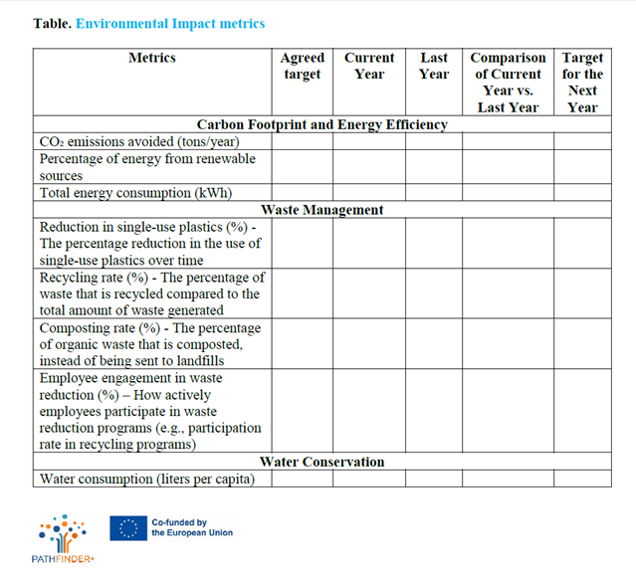
Social Impact Metrics are provided in Table below. 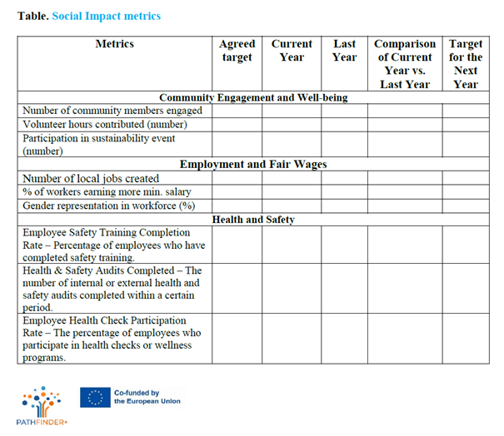
Economic Impact Metrics are provided in Table below. 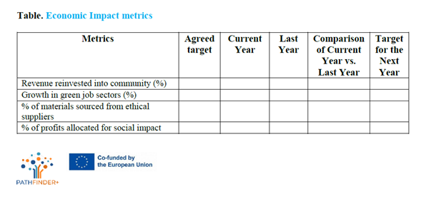

5. PATHFINDER+ Participatory Impact Assessment Tool
A participatory impact assessment tool is a structured way to evaluate the real changes generated by a project (or expected by the project), not just from the organisations´s perspective, but taking into account the target group, the groups involved and the beneficiaries themselves. This bottom up approach makes the evaluation process more inclusive, meaningful and actionable. The tool will provide valuable insights into the effectiveness of the project proposal and a way to ongoing adaptation to the target group needs and challenges.
WHEN TO USE THE TOOL
- During Pilot Testing - to gather initial feedback before scaling.
- At project milestones - to assess progress and refine strategies.
- Post-implementation - to measure long-term impact and report to stakeholders.
- For funding and scaling - to demonstrate effectiveness and attract investors or partners.
TOOL CONTRIBUTION
Ensures community participation as it engages beneficiaries and the different groups involved as active contributors to the project.
Provides insights into what's working or what is valuable and what may need to be improved. This process facilitates continuous learning to adapt strategies and for long-term sustainability.
Supports reporting to funders, partners and the community.
Link to online template: https://participatory-impact-assessment-template--oldantelope6059299.on.websim.ai

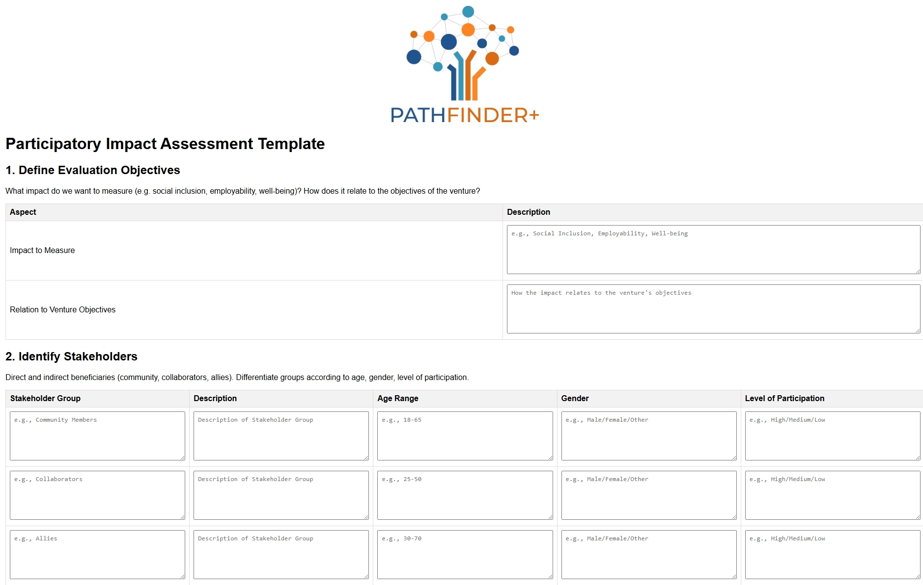
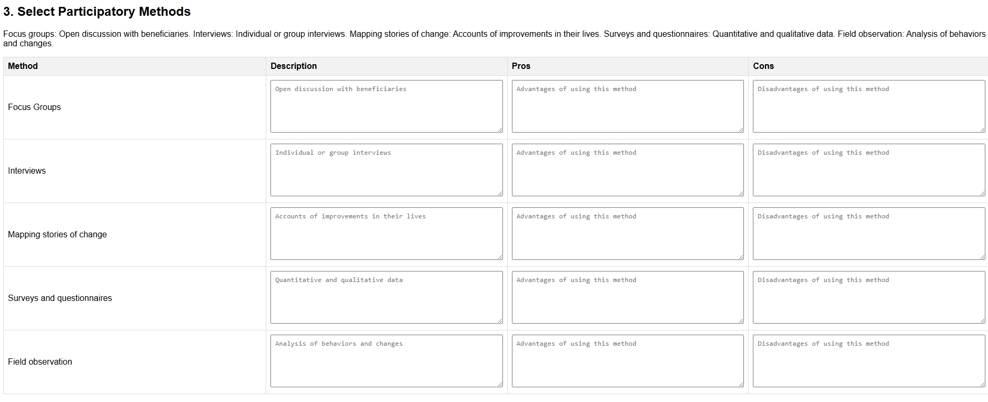
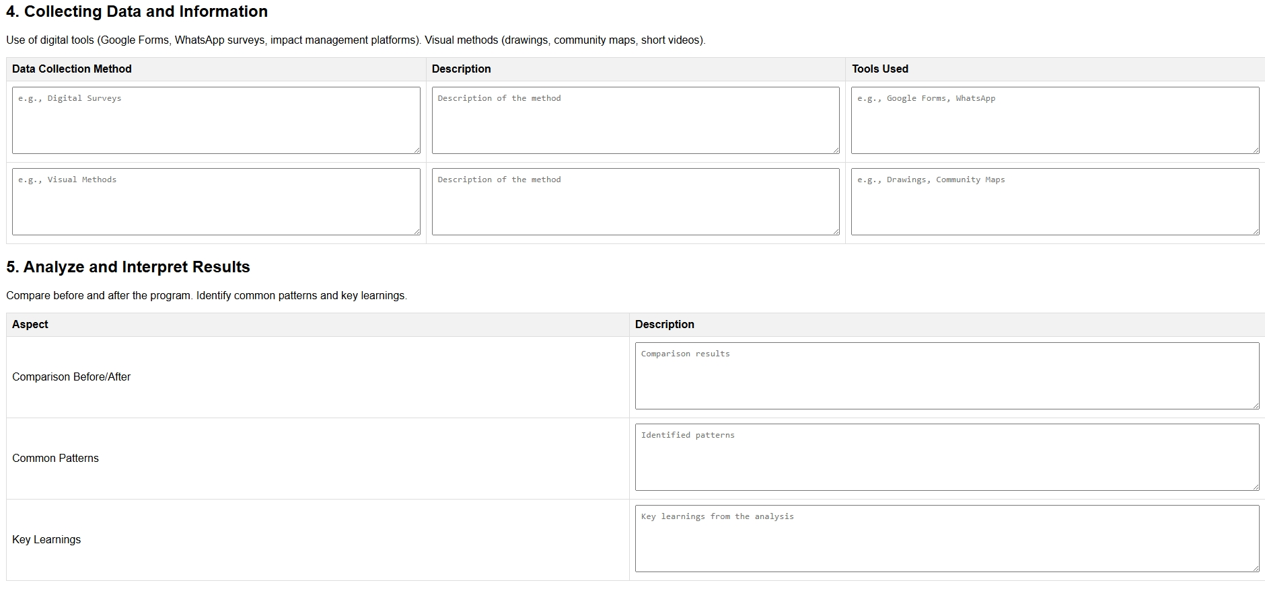
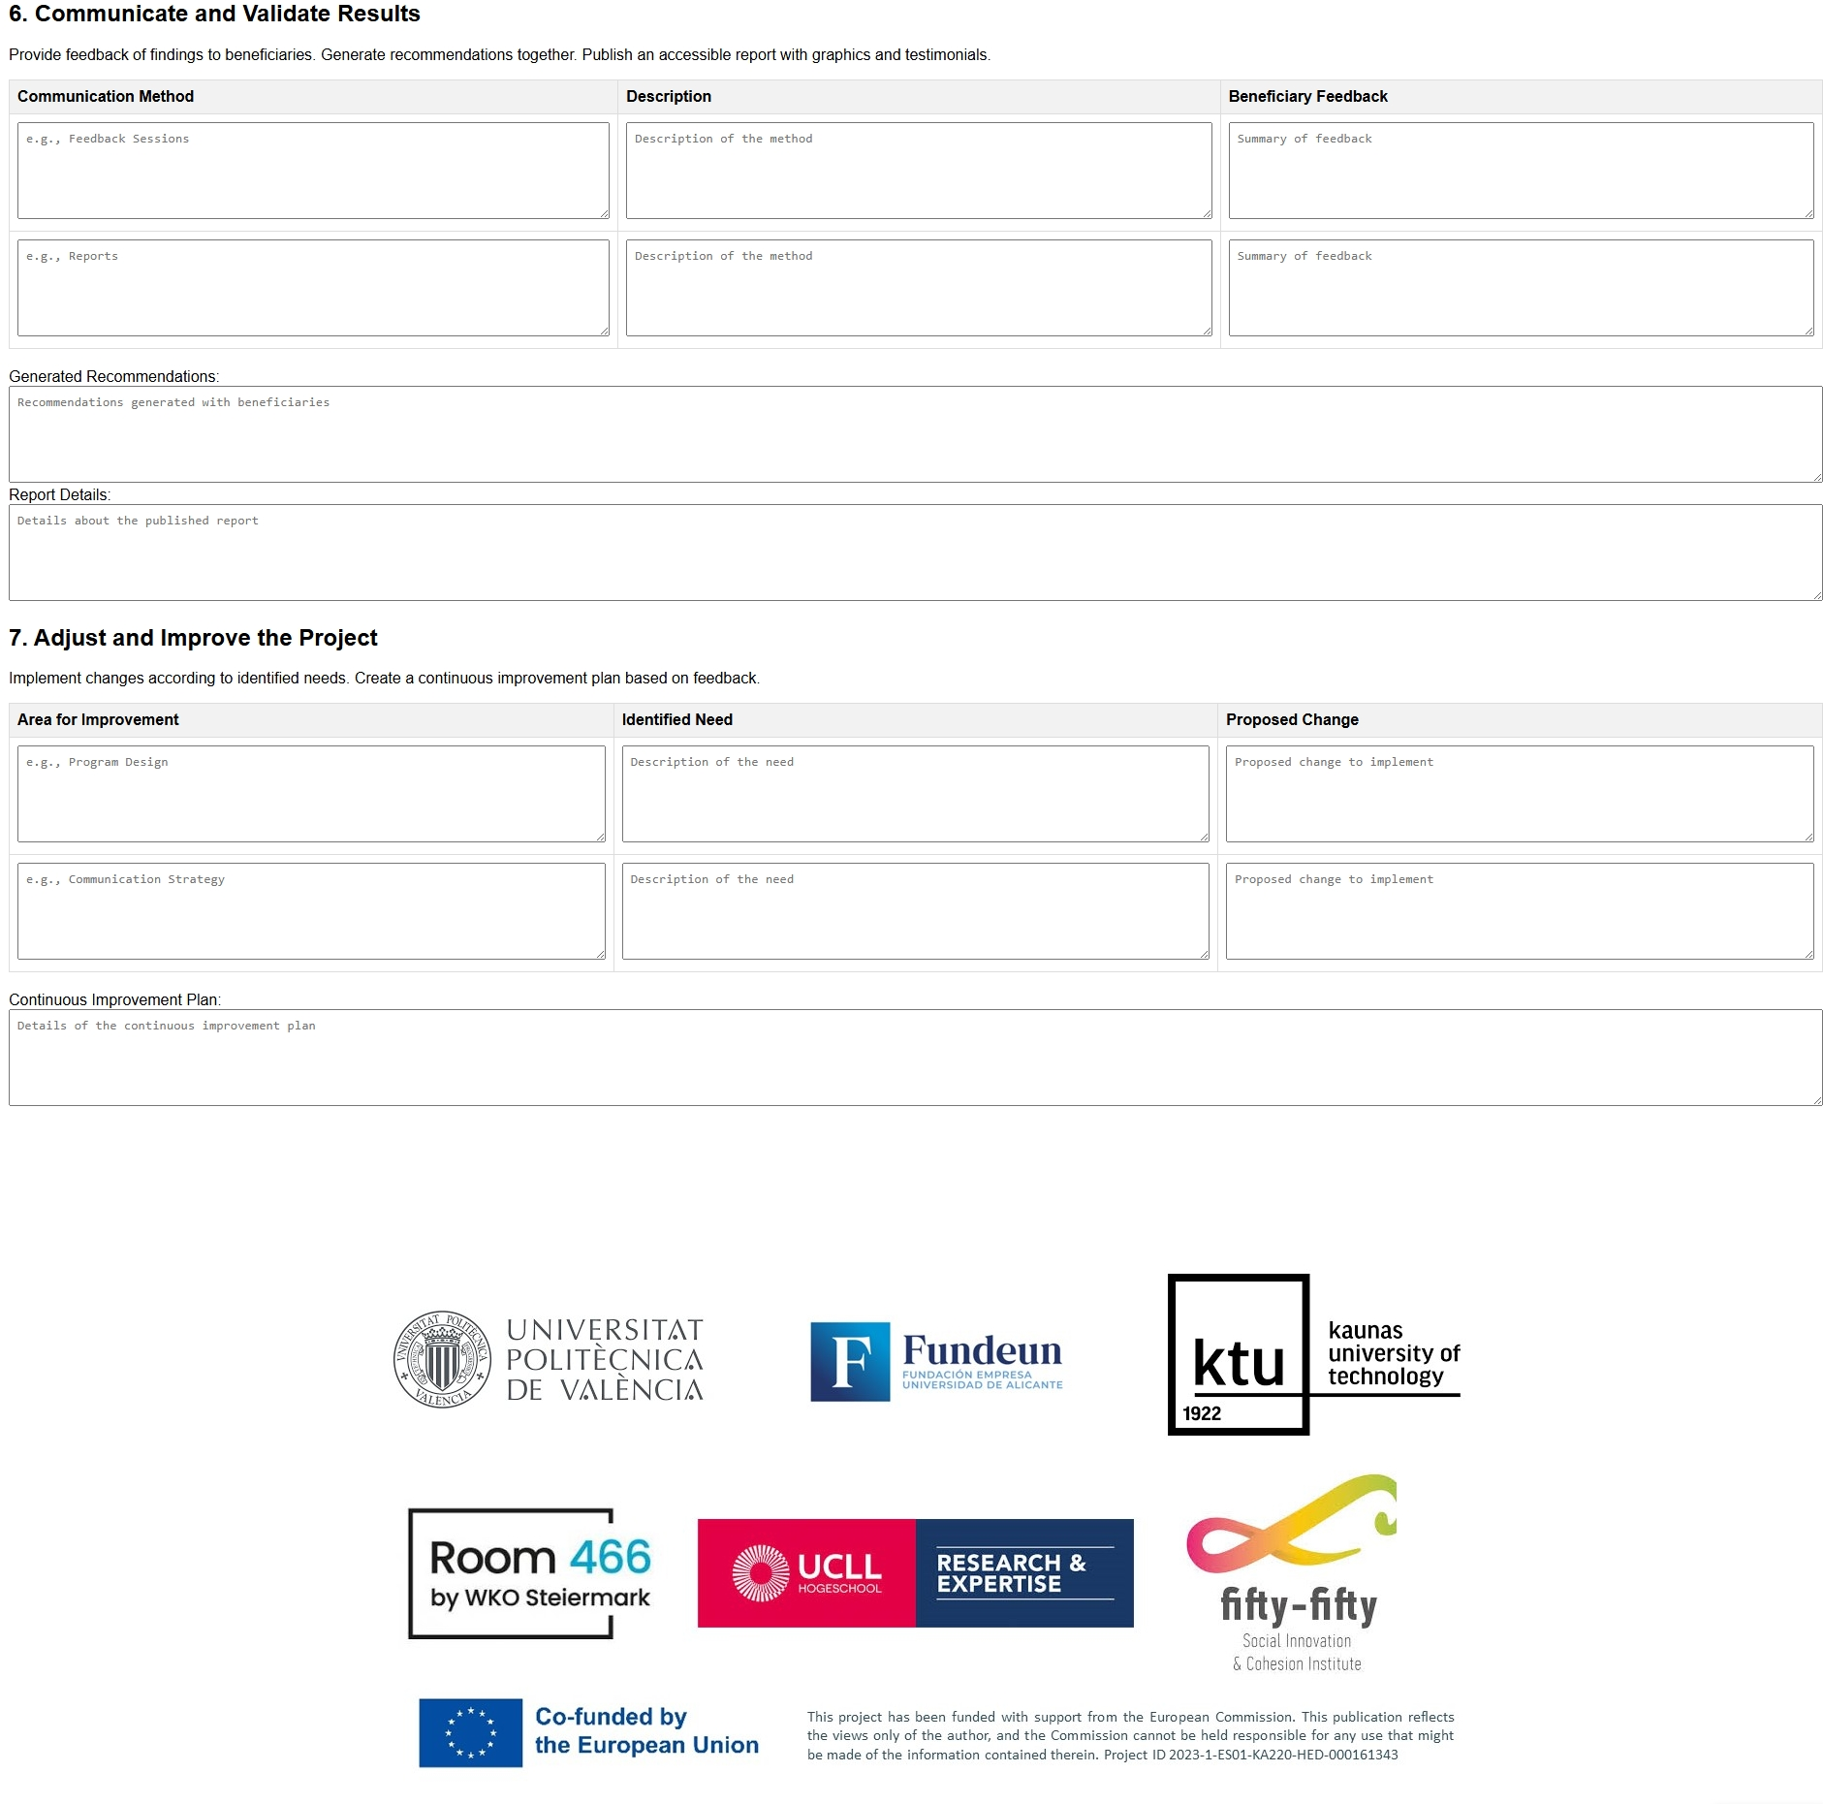

Unit 5 – Case studies
This section provides 4 real-world examples of community-led enterprises that have successfully applied tools from the toolkit. These case studies showcase how tools like the business model canvas, stakeholder map and SWOT analysis have been practically implemented to drive growth, sustainability and community involvement. Each case study highlights the specific tool used, the challenges faced and the outcomes achieved, serving as a practical guide for other community-led projects.

Case Study 1: Mondragon Cooperative Corporation, Spain
Tool Used: Business Model Canvas
Summary: The Mondragon Cooperative Corporation, one of the largest worker-owned cooperatives in the world, applied the Business Model Canvas to streamline its operations across multiple business sectors. The cooperative used the tool to clearly define its community-focused value proposition, ensuring that worker-owners had a voice in decision-making and profit distribution. The tool also helped in identifying key partners within the Pais Vasco region (Spain) to support expansion efforts while staying true to its cooperative principles.
Challenges: Ensuring democratic governance and maintaining economic resilience during economic downturns.
Solution Using the Tool: By clearly defining its Key Partners (local institutions, businesses, and community organizations) and reinforcing its Social Value Proposition (job creation and community ownership), the cooperative was able to weather economic downturns by reinvesting profits into community projects.
Outcome: The cooperative has successfully maintained high employment levels and reinvested a significant portion of its profits back into the community. The Business Model Canvas was integral in visualizing these key components and ensuring long-term success.
Source: https://www.mondragon-corporation.com/en/

Case Study 2: Pla Buits Urban Gardens, Barcelona, Spain
Tool Used: SWOT Analysis
Summary: The Pla Buits initiative in Barcelona repurposed unused urban spaces into community gardens. The project used SWOT Analysis to assess internal strengths and external opportunities, which was key to navigating both the legal hurdles and community buy-in necessary for success.
Challenges: Finding suitable land and ensuring that the local government supported the use of public spaces for community projects.
Solution Using the Tool: The SWOT Analysis helped identify the Strengths of the initiative, including the community’s desire for green spaces and sustainable development. It also highlighted Threats, such as potential regulatory changes. By proactively addressing these, the project team was able to partner with the local government to secure long-term use of the land.
Outcome: The initiative transformed temporary unused urban spaces into thriving urban gardens that contribute to local food production, social cohesion, and environmental sustainability.
Source: https://una.city/nbs/barcelona/social-urban-gardens-pla-buits-vacant-lots-plan

Case Study 3: Grow Green, Manchester, UK
Tool Used: Stakeholder Map
Summary: Grow Green is a community-led project in Manchester aimed at promoting green infrastructure and sustainable urban development. The team used a Stakeholder Map to identify key community leaders, local businesses, government officials, and environmental groups who could support the project.
Challenges: Securing investment and support from diverse stakeholders to fund and implement sustainable infrastructure projects.
Solution Using the Tool: The Stakeholder Map helped the Grow Green team pinpoint the most influential stakeholders who had the resources to make the project a success. By categorizing stakeholders based on their level of interest and influence, the team was able to tailor its engagement strategy, ensuring that the right stakeholders were involved at the right time.
Outcome: The project secured significant local government support and funding from both public and private partners. It resulted in the successful implementation of green spaces, improved urban water management, and increased community engagement in environmental sustainability.
Source: https://growgreenproject.eu/

Case Study 4: Enercoop, France
Tool Used: Business Model Canvas & Stakeholder Map
Summary: Enercoop is a community-led renewable energy cooperative in France. The cooperative used both the Business Model Canvas and the Stakeholder Map to align its goals with community needs and identify key partners for funding and expansion.
Challenges: Finding a sustainable business model that could scale while maintaining community ownership.
Solution Using the Tools: The Business Model Canvas helped Enercoop define its Value Proposition centered around renewable energy access for all, while the Stakeholder Map identified key partnerships with local governments, community organizations, and renewable energy suppliers. These tools allowed the cooperative to expand its reach across multiple regions of France while staying true to its core mission.
Outcome: Enercoop successfully grew into a national energy provider, maintaining its cooperative ownership structure while becoming a leader in renewable energy. The tools helped the cooperative align its resources and partnerships to achieve scalable growth.
Source: https://www.enercoop.fr/

Conclusion
This toolkit created by the Erasmus+ Pathfinder project constitutes a user-friendly guide for entrepreneurs and community-led businesses, as it composes and synthesizes the essential components aimed at fostering thriving community-based enterprises. It brings together a set of strategic tools, including detailed case studies, and templates meticulously crafted by Pathfinder. These resources collectively serve to empower stakeholders with practical knowledge and proven methodologies, ensuring sound project management and enhancement of skills crucial for sustainable community development. The tools created by Pathfinder in this manual have been adapted based on the previous knowledge and research carried out by this project to be fully targeted to support and meet the needs and constraints of community entrepreneurs. Likewise, these tools and their templates are a basis for their users to also adapt them based on the type of company, project or strategies and objectives pursued, therefore, stakeholders must embrace continuous innovation, collaborative efforts and exploration of emerging trends to effectively meet the changing needs of the community.
In conclusion, the Pathfinder Project aims to ensure accessibility, support and guidance to community entrepreneurs by reinforcing the commitment to facilitate impactful community initiatives through the informed and strategic implementation of the toolset's resources. Ultimately, the conclusion underscores the toolkit's critical role in driving positive change, fostering resilience and empowering communities to thrive independently and inclusively.

References
Doran, G. T. (1981). There's a S.M.A.R.T. way to write management's goals and objectives. Management Review, 70(11), 35–36.
Ecochain. (n.d.). Ecochain. Retrieved from https://www.ecochain.com/
Enercoop. (n.d.). Enercoop. Retrieved from https://www.enercoop.fr/
Global Reporting Initiative. (n.d.). GRI Standards. Retrieved from https://www.globalreporting.org/standards/
GreenDelta. (n.d.). OpenLCA. Retrieved from http://www.openlca.org/
Grow Green Project. (n.d.). Grow Green Project. Retrieved from https://growgreenproject.eu/
Impact Management Project. (n.d.). Impact Management Project. Retrieved from https://impactmanagementproject.com/
Lithuanian Responsible Business Association. Retrieved form https://atsakingasverslas.lt/en/home/
Mondragon Cooperative Corporation. (n.d.). Mondragon Cooperativbe Corporation. Retrieved from https://www.mondragon-corporation.com/en/
Osterwalder, A., & Pigneur, Y. (2010). Business model generation: A handbook for visionaries, game changers, and challengers. Wiley.
Panagiotou, G. (2003). Bringing SWOT into focus. Business Strategy Review, 14(2), 8–10.
Ries, E. (2011). The Lean Startup: How today's entrepreneurs use continuous innovation to create radically successful businesses. Crown Business.
UN Global Compact. Retrieved from https://unglobalcompact.org/
Una City. (n.d.). Social urban gardens: Pla Buits vacant lots plan. Retrieved from https://una.city/nbs/barcelona/social-urban-gardens-pla-buits-vacant-lots-plan
Yüksel, I. (2012). Developing a multi‐criteria decision making model for PESTEL analysis: A case study. International Journal of Business and Management, 7(24), 52–66.

